Name

Mathematics Advanced Year 11
Linear Functions

Book 1 |  | Version: 261020  Feedback:  https://MrDingMaths.com
Contents
Syllabus Content 2
Learning Intention 3

Syllabus Content
MAV-11-02 uses functions and relations to model, analyse and solve problems
Linear functions
- Determine the equations of straight lines in gradient–intercept form $y=mx+c$ with gradient $m$ and $y$-intercept $c$
- Determine the equations of straight lines in general form $ax+by+c=0$, where $a$, $b$ and $c$ are constants
- Determine the equation of a straight line passing through a point $\left(x_{1},y_{1}\right)$ with gradient $m$ using the point–gradient formula $y-y_{1}=m\left(x-x_{1}\right)$
- Determine the equation of a straight line passing through two points $\left(x_{1},y_{1}\right)$ and $\left(x_{2},y_{2}\right)$ by calculating its gradient $m$ using the formula $m=\frac{y_{2 }- y_{1}}{x_{2 }- x_{1}}$
- Determine the $x$-intercept and $y$-intercept of a straight line given its equation
- Choose and apply appropriate techniques to graph a straight line given its equation
- Find the equation of a line that is parallel or perpendicular to a given line
- Solve linear inequalities and graph the solution on a number line

Gradient-Intercept Form and General Form

- Gradient-Intercept Form
Every linear relationship has this equation:
$$y=mx+c$$

coefficient of $x$ constant term
gradient $y$-intercept

- Determine gradient and $y$-intercept from an equation
$$y=2x+7$$  Gradient: 2  $y$-intercept: $\left(0,7\right)$ | $$y=2x-7$$  Gradient: 2  $y$-intercept: $\left(0,-7\right)$ | $$y=\frac{2x}{5}-7$$  Gradient: $\frac{2}{5}$  $y$-intercept: $\left(0,-7\right)$
Determine the gradient and $y$-intercept of these lines.
- $y=3x+2$ | - $y=3x-2$ | - $y=-3x+2$
- $y=2-3x$ | - $y=$ $\frac{5x}{4}$ $-1$ | - $y=7x$

- Determine equation of a line, given the gradient and $y$-intercept
Find the equation of a line with:
gradient 3 and $y$-intercept $(0,4)$.  $$y=3x+4$$ | gradient 3 and $y$-intercept $(0,-4)$.  $$y=3x-4$$ | gradient $-\frac{1}{2}$ and $y$-intercept $(0,0)$.  $$y=-\frac{x}{2}$$
Find the equation of a line with:
- gradient 3 and  $y$-intercept $(0,4)$. | - Gradient is $-2$ and  $y$-intercept is $\left(0,3\right)$ | - $y$-intercept is $(0,-1)$ and gradient is $5$
- $y$-intercept is $\left(0,2\right)$ and gradient is $\frac{2}{3}$ | - Gradient is 1 and  $y$-intercept is $\left(0,-4\right)$ | - $y$-intercept is $\left(0,-9\right)$ and gradient is $-\frac{5}{6}$

- Example Identify gradient and y-intercept after rearranging the equation
Rearrange the equation, then identify the gradient and $y$-intercept.
$y-7=2x$  $y=2x+7$  Gradient: 2  $y$-intercept: 7 | $3y+15-2x=0$  $3y=2x-15$  $y=$ $\frac{2x}{3}$ $-$ $\frac{15}{3}$  Gradient: $\frac{2}{3}$  $y$-intercept: $-5$

- Guided Practice
Rearrange the equation, then identify the gradient and $y$-intercept.
- $y+2x=5$  $$m=-2, c=5$$ | - $x-y=7$  $$m=1, c=-7$$
- $4x+2y=1$  $$m=-2, c=0.5$$ | - $-2x-5y=3$  $$m=-\frac{2}{5}, c=-\frac{3}{5}$$

- General Form of a Line
The general form of a line is:
$$ax+by+c=0$$

Where $a,b,c$are expressed as integers if possible, and $a$ is preferred to be positive.

- Identify General form of a line
✖  $$y=3x+5$$ | ✔  $$3x-y+5=0$$ |  | ✔  $$99x+25y=0$$ |  | ✖  $$-99x+25y=0$$
Identify the lines written in general form:
- $y=2x+3$ |  | - $2x-y+3=0$ |  | - $x-3y+6=0$
- $-x+3y-6=0$ |  | - $0.5x+y-2=0$ |  | - $3x-4y-$ $\frac{1}{5}$ $=0$

- Example Rearrange an equation of a line to general form.
Rearrange $y=3x-7$ to general form.
$$-3x+y+7=0$$
$3x-y-7=0$

- Guided Practice
Rearrange to general form.
- $y=5x-2$  $$5x-y-2=0$$ | - $y=\frac{1}{2}x-3$  $$x-2y-6=0$$
- $y=2x-\frac{3}{5}$  $$10x-5y-3=0$$ | - $y=\frac{x}{4}+\frac{1}{3}$  $$3x-12y+4=0$$

- Checking if a Point Lies on a Line
A point lies on a line when its coordinates make the line's equation true.
- Separate the left-hand side LHS and right-hand side RHS of the equation.
- Substitute $x$ and $y$ values of the point into both sides.
- Compare: If LHS = RHS, it lies on the line. If LHS ≠ RHS, it does not lie on the line.

- Example Check whether a point lies on a line by substitution
Decide whether $(2,5)$ lies on the line  $$y=2x+1$$ | Decide whether $(-2,-5)$ lies on the line  $$y=2x+1$$
  $LHS=y$  $=5$ | $RHS=2x+1$  $=2\left(2\right)+1$  $=5$
  $$LHS=RHS$$
  $(2,5)$ lies on the line $y=2x+1$
  $LHS=y$  $=-5$ | $RHS=2x+1$  $=2\left(-2\right)+1$  $=-3$
  $$LHS≠RHS$$
  $(-2,-5)$ does not lie on line $y=2x+1$

- Guided Practice
- Decide whether $(-2,4)$ lies on the line  $$y=-x+2$$  yes | - Decide whether $(11,23)$ lies on the line  $$y=35-x$$  no
  $LHS=$ | $RHS=$
  $LHS=$ | $RHS=$

Sketching Lines

- Sketching Lines without a Table
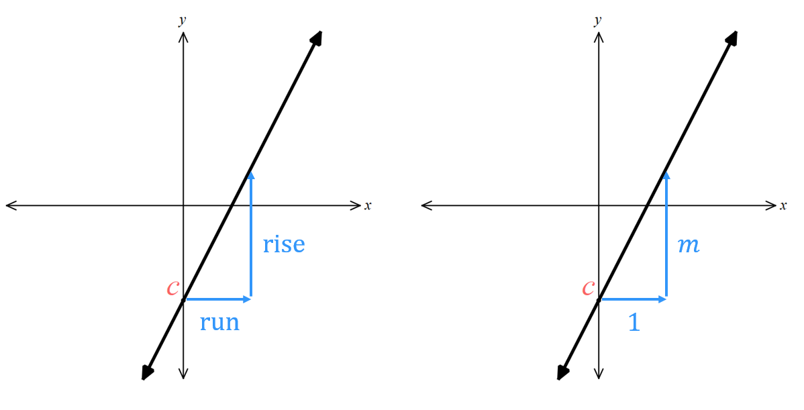
$y=mx+c$

- Plot the $y$-intercept.
- Starting from the $y$-intercept, use the gradient to find another point.
  - The denominator is how much to move right (1 if the gradient is a whole number).
  - The numerator is how much to move up or down.
- Draw a straight line through both points and extend the line.

- Example Sketch lines from the equation using gradient and $y$-intercept
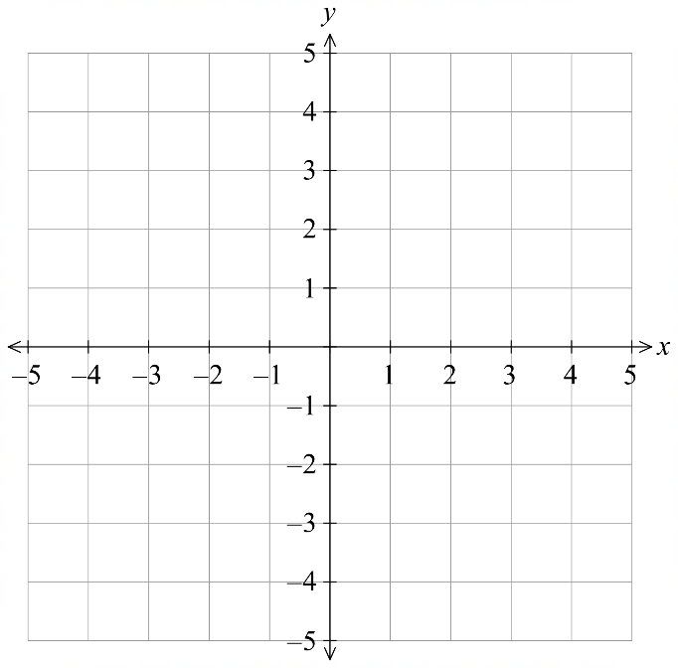
Sketch $y=3x-1$
Step 1.
Step 2.
1. Plot a point at $(0,-1)$

2. The gradient is 3. Starting at $(0,-1)$:
Move right 1 unit.
Move up 3 units.

3. Join the two points and extend the line.

Sketch $y=-\frac{4}{3}x+2$
Step 1.
Step 2.
1. Plot a point at $(0,2)$

2. The gradient is $-\frac{4}{3}$. Starting at $(0,2)$:
Move right 3 units.
Move down 4 units.

3. Join the two points and extend the line.

- Guided Practice
- Sketch $y=3x+2$  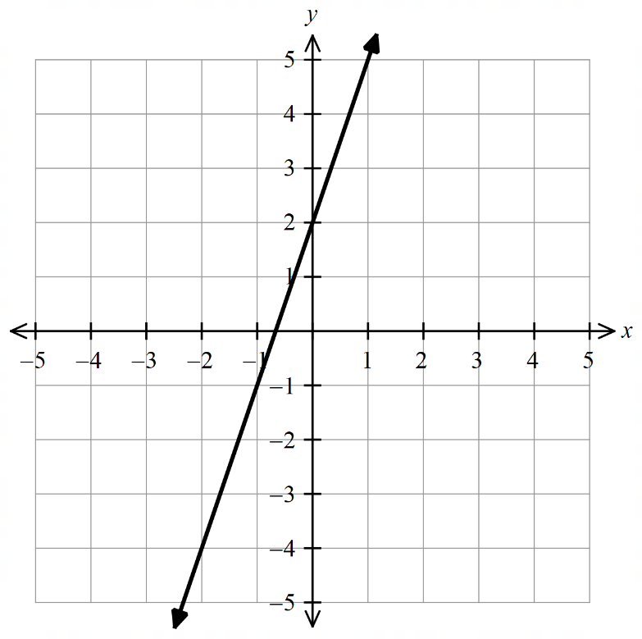 | - Sketch $y=3x-4$  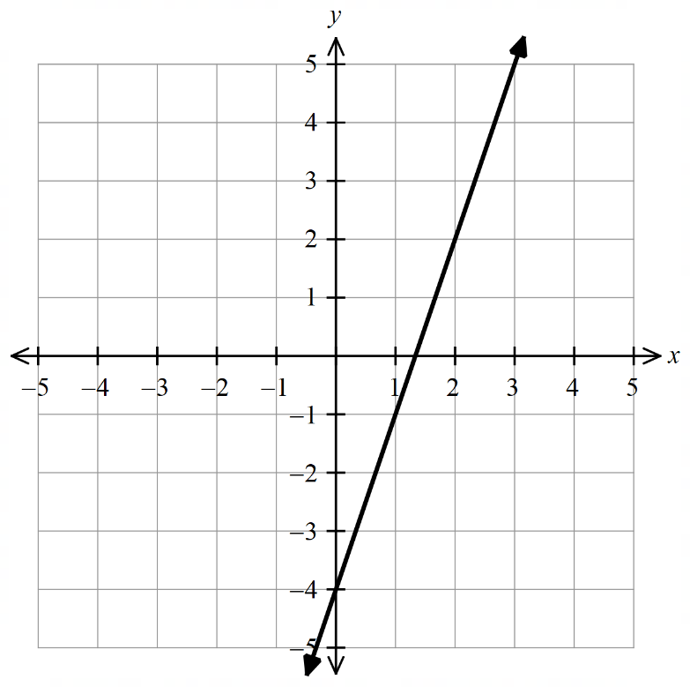
- Sketch $y=-2x+1$  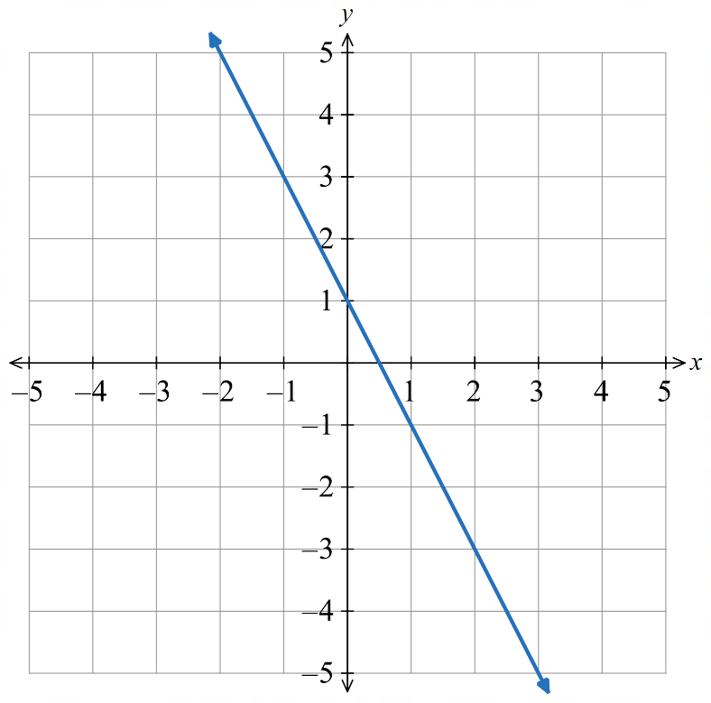 | - Sketch $y=\frac{3x}{4}-2$  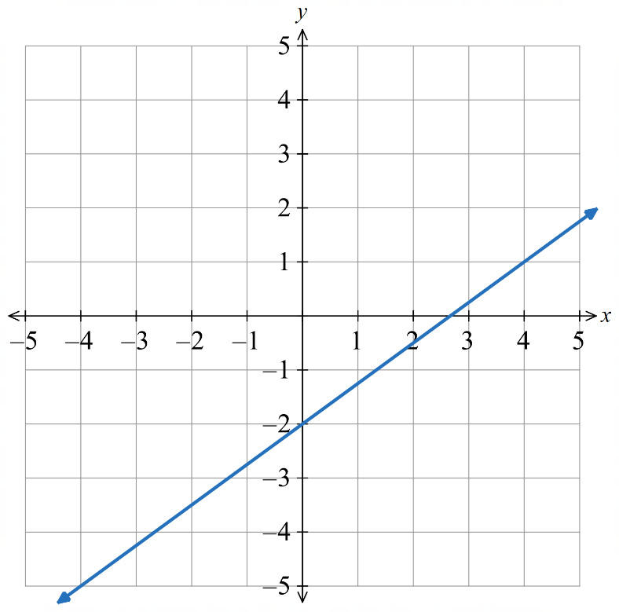
- Sketch $y=-\frac{x}{2}+3$  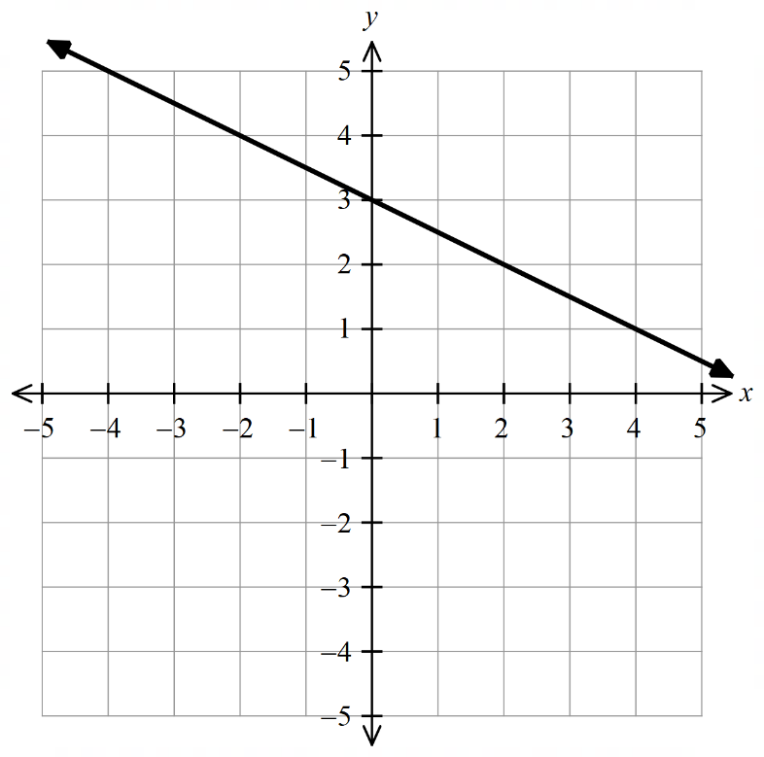 | - Sketch $y=-x-\frac{1}{2}$  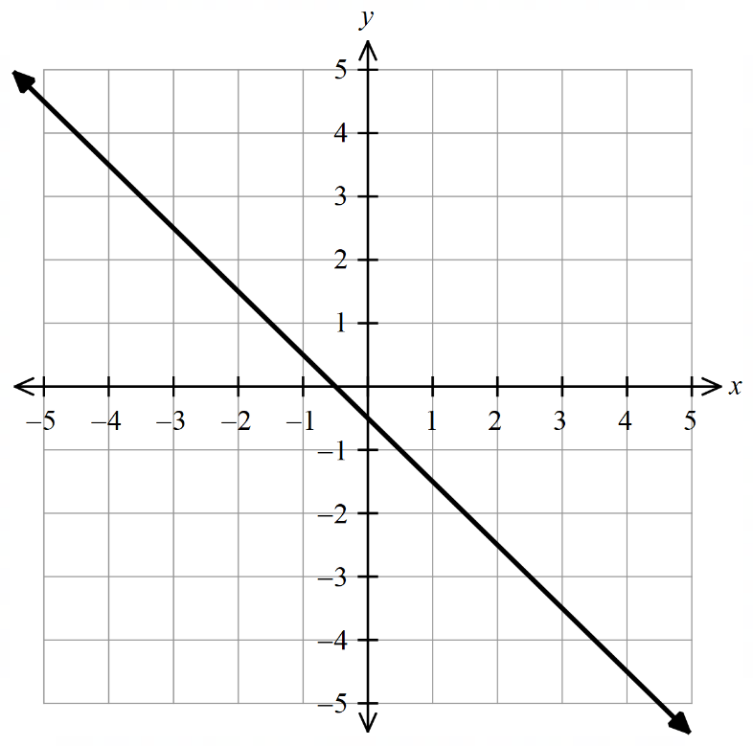

- $x$ and $y$ intercepts
$x$-intercept: where the line meets the $x$ axis $\left(y=0\right)$
$y$-intercept: where the line meets the $y$ axis $(x=0)$
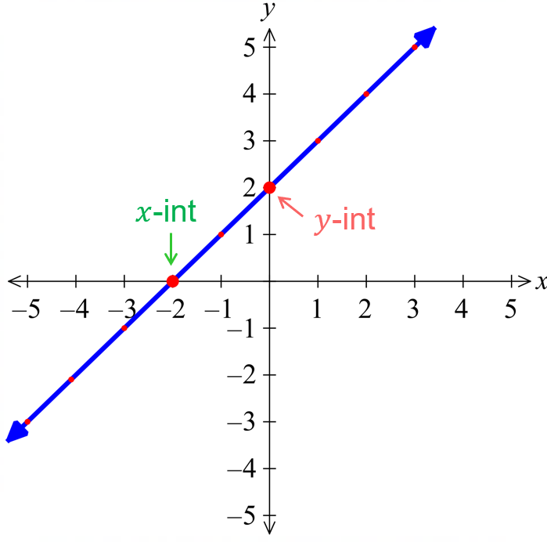
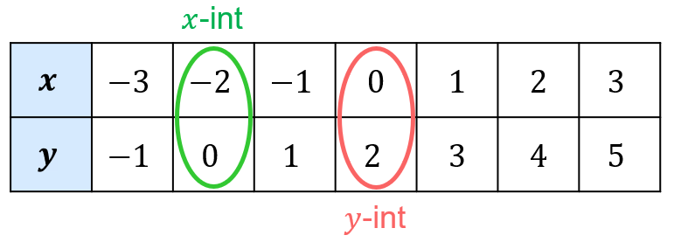

- Identify $x$ and $y$ intercepts of a line
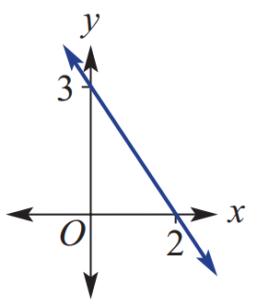  $x$-intercept: ……… $y$-intercept: ……… | $x$-intercept: ……… $y$-intercept: ………
  $$x$$ | $$-2$$ | $$-1$$ | 0 | 1 | 2
  $$y$$ | $$-6$$ | $$-4$$ | $$-2$$ | 0 | 2
$x$-intercept: ……… $y$-intercept: ……… | 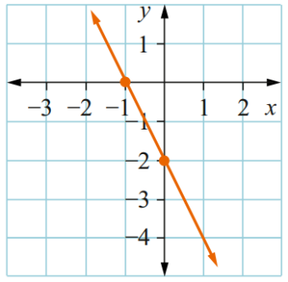  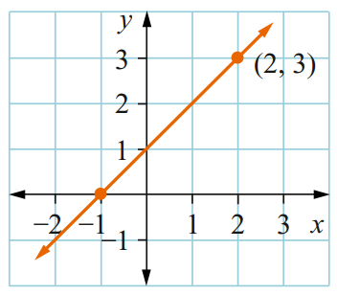  $x$-intercept: ……… $y$-intercept: ………
$x$-intercept: ……… $y$-intercept: ……… | $x$-intercept: ……… $y$-intercept: ………
  $$x$$ | $$-2$$ | $$-1$$ | $$0$$ | $$1$$ | $$2$$
  $$y$$ | $$2$$ | $$0$$ | $$-2$$ | $$-4$$ | $$-6$$
  $$x$$ | $$-2$$ | $$-1$$ | $$0$$ | $$1$$ | $$2$$
  $$y$$ | $$-9$$ | $$-6$$ | $$-3$$ | $$0$$ | $$3$$

- Finding the $x$ and $y$ intercepts
$y$ intercept: substitute $x=0$ and solve.
$x$ intercept: substitute $y=0$ and solve.

- Example Identify $x$ and $y$ intercept from the equation
Find the $x$ and $y$ intercepts of  $$y=4x+2$$ | Find the $x$ and $y$ intercepts of  $$x+2y-6=0$$
  $y$-int: $x=0$  $$y=4\left(0\right)+2 \\ y=2$$  $y$-int is at $(0,2)$ | $x$-int: $y=0$  $$0=4x+2 \\ -2=4x \\ -\frac{2}{4}=x \\ -0.5=x$$  $x$-int is at $(-0.5 ,0)$
  $y$-int: $x=0$  $$0+2y-6=0 \\ 2y=6 \\ y=3$$  $y$-int is at $(0,3)$ | $x$-int: $y=0$  $$x+2\left(0\right)-6=0 \\ x-6=0 \\ x=6$$$x$-int is at $(6 ,0)$

- Guided Practice
Find the $x$ and $y$ intercepts of these lines.
- $y=2x-8$  $x$-int: $(4,0)$, $y$-int: $\left(0,-8\right)$ | - $x-y=7$  $x$-int: $\left(7,0\right)$, $y$-int: $\left(0,-7\right)$
  $y int:$ $x=0$  $y=2\left(0\right)-8$ | $x int:$ $y=0$  $0=2x-8$
  $y int:$ $x=0$ | $x int:$ $y=0$
- $-3x-2y=6$  $x$-int: $\left(-2,0\right)$, $y$-int: $\left(0,-3\right)$ | - $4x+4y=7$  $x$-int: $\left(\frac{7}{4},0\right)$, $y$-int: $\left(0,\frac{7}{4}\right)$

- Sketching lines using the intercepts
- Find the $y$ intercept ($x=0$)
- Find the $x$ intercept ($y=0$)
- Connect the $x$ and $y$ intercept and extend the straight line.

- Example Sketch graphs from the equation by finding the intercepts
Sketch $x+2y+6=0$ | 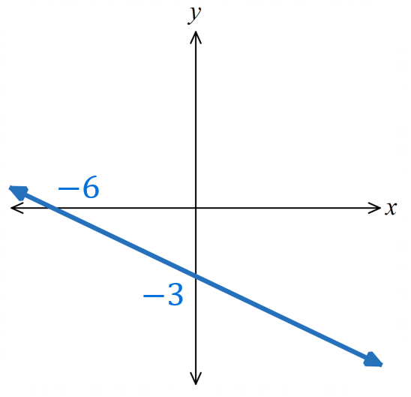  3.
  1. $y$-int: $x=0$  $2y+6=0$  $2y=-6$  $y=-3$ | 2. $x$-int: $y=0$  $$x+6=0$$  $x=-6$

- Guided Practice
Sketch by finding the intercepts:
- $3y=4x-6$  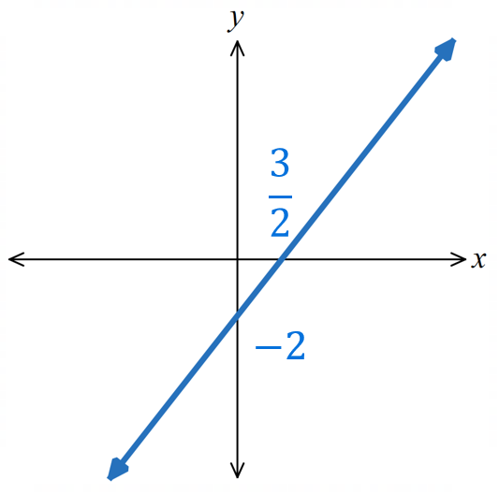 |  | - $4x-2y=14$  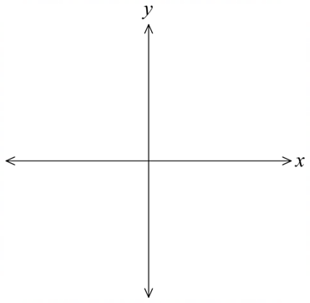  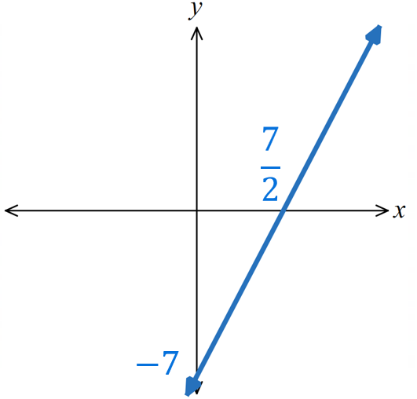
- Special Lines
Horizontal Line  $$y=c$$  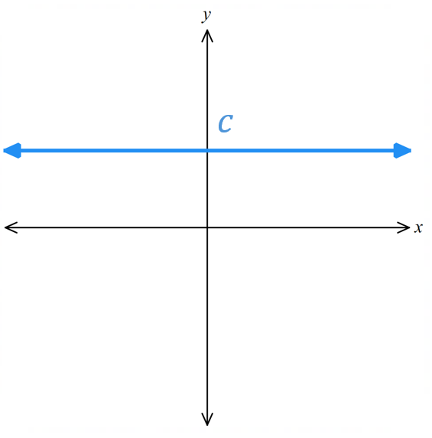 | Vertical Line  $$x=k$$  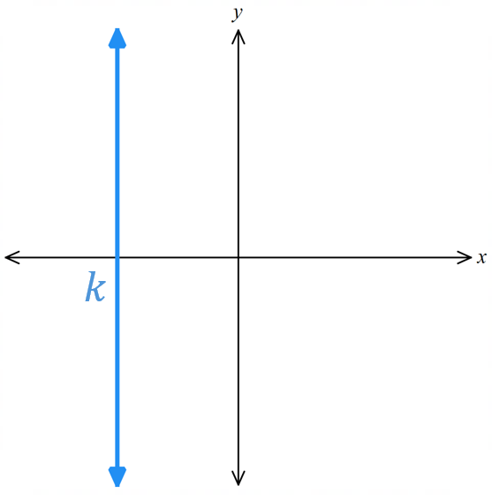 |  | Straight line through origin  $$y=mx$$  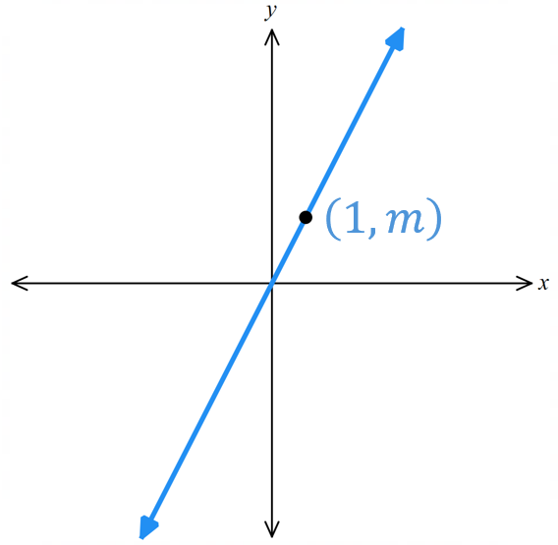

- Sketch Special lines
For each equation, sketch the line, showing the intercept for horizontal/vertical lines, and the coordinate at $x=1$ for lines through the origin.
- $x=-1$ | - $y-2=0$ | - $2y=-3$  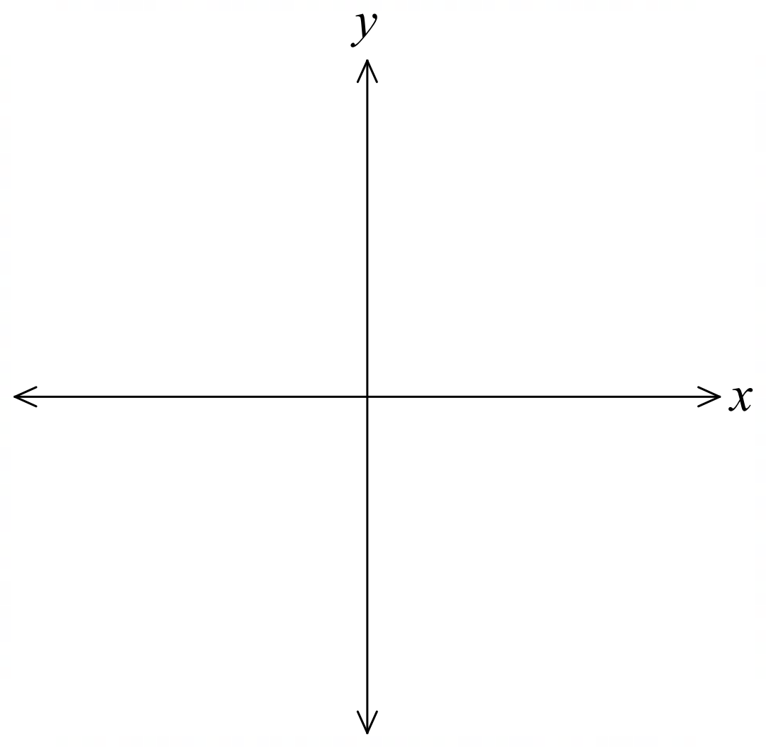
- $x+2y=0$ | - $3x-5y=0$ | - $2x=5$

Point-Gradient Form

- Point-Gradient Formula
The point-gradient formula of a line relates the gradient $m$ and any point on the line $\left(x_{1},y_{1}\right)$

gradient

$$y-y_{1}=m\left(x-x_{1}\right)$$
$\begin{matrix}y coordinate \\ of a point\end{matrix}$ $\begin{matrix}x coordinate \\ of a point\end{matrix}$

- Example Find equation of a line given gradient and a point
Find the equation of the line with  gradient $3$ passing through $(6,4)$.  $m$ $x_{1} y_{1}$  $$y-y_{1}=m(x-x_{1}) \\ y-4=3(x-6) \\ y-4=3x-18 \\ y=3x-14$$ | Find the equation of the line with  gradient $-4$ and $x$ intercept 1.  $m$ $\left(x_{1} y_{1}\right)=\left(1,0\right)$  $$y-y_{1}=m(x-x_{1}) \\ y-0=-4\left(x-1\right) \\ y=-4x+4$$

- Guided Practice
Find the equation of the line, in gradient-intercept form, with:
- Gradient 4 and passes through $(-1,2)$  $$y=4x+6$$ | - Gradient 3 and passes through $(-3,5)$  $$y=3x+14$$
- Gradient $\frac{1}{3}$ and passes through $(9,2)$  $$y=\frac{x}{3}-1$$ | - Gradient $-3$ passes through $(8,-5)$  $$y=-3x+\frac{13}{3}$$

- Finding Equation of a Line given Two Points
- Calculate gradient using the formula: $m=$ $\frac{y_{2}-y_{1}}{x_{2}-x_{1}}$
- Substitute into point-gradient form. $y-y_{1}=m(x-x_{1})$
- Rearrange to $y=mx+c$.

- Example Find equation of a line given two points
Find the equation of the line, in gradient-intercept form, passing through $(1, 5)$ and $(4, -1)$
1. $m=$ $\frac{y_{2}-y_{1}}{x_{2}-x_{1}}=$ $\frac{-1-5}{4-1}$ $=-2$2. Sub $m=-2$ and (1,5)
$$y-y_{1}=m(x-x_{1}) \\ y-5=-2\left(x-1\right)$$3. $y-5=-2x+2$ $y=-2x+7$

- Guided Practice
Find the equation of the line, in gradient-intercept form, passing through:
- $(2,7)$ and $(-1.5,0)$  1. $m=$ $\frac{y_{2}-y_{1}}{x_{2}-x_{1}}$  2. $y-y_{1}=m(x-x_{1})$  3.  $$y=2x+3$$ | - $(1,7)$ and $(3,-1)$  $$y=-4x+11$$
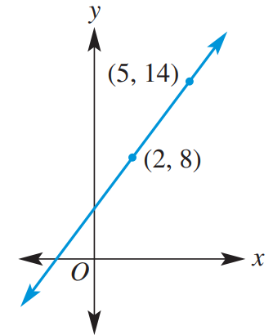  $$y=2x+4$$ | 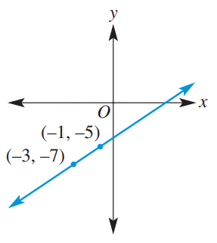  $$y=x-4$$

Parallel and Perpendicular Lines

- Parallel and Perpendicular Gradients
Parallel lines have the same gradient.
Perpendicular lines have gradients that multiply to $-1$.
Consider two lines $y=m_{1}x+c_{1}$ and $y=m_{2}x+c_{2}$.
Parallel Lines  $$m_{1}=m_{2}$$ | 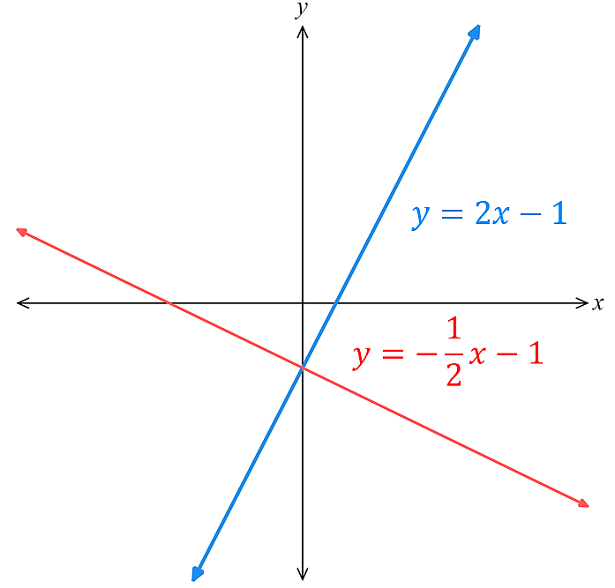  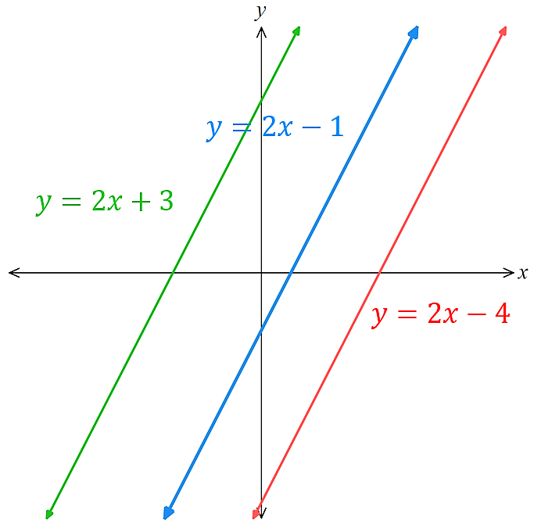  Perpendicular Lines  $$m_{1}×m_{2}=-1 \\ m_{1}=-\frac{1}{m_{2}}$$

- Identify whether two lines are parallel, perpendicular, or neither
$y=3x-1$ $m_{1}=3$  $y=3x+4$ $m_{2}=3$  Parallel | $y=4x-2$ $m_{1}=4$  $y=-\frac{1}{4}x+3$ $m_{2}=-\frac{1}{4}$  Perpendicular | $y=2x+1$ $m_{1}=2$  $y=-2x-5$ $m_{2}=-2$  Neither
Decide whether these lines are parallel, perpendicular, or neither.
- $y=-\frac{1}{5}x+1$  $$y=5x+2$$ | - $y=2x+1$  $$y=2x-100$$ | - $y=7x-2$  $$y=-7x+2$$
- $y=10-2x$  $$y=10+2x$$ | - $y=$ $\frac{3}{4}$ $x$  $$y=-\frac{4}{3}x$$ | - $y=3$  $$x=3$$

- Finding the Equation of a Parallel and Perpendicular Line
Gradient of a Parallel Line  $$m_{par}=m_{original}$$ | Gradient of Perpendicular Line  $$m_{perp}=-\frac{1}{m_{original}}$$
- Determine gradient $m_{new}$ of the parallel/perpendicular line.
- Write the equation $y-y_{1}=m_{new}(x-x_{1})$
- Substitute new gradient and given point into the formula.
- Rearrange to $y=mx+c$

- Example Find the equation of a parallel/perpendicular line
Find the equation of a line, in gradient-intercept form, that is:
Parallel to $y=-2x-7$ through $(1,9)$  1. $m_{new}=-2$  2. $y-y_{1}=m_{new}\left(x-x_{1}\right)$3. $y-9=-2\left(x-1\right)$4. $y-9=-2x+2$ $y=-2x+11$ | Perpendicular to $y=\frac{3}{4}x-1$ through $(3,-2)$  1. $m_{new}=-$ $\frac{4}{3}$  2. $y-y_{1}=m_{new}\left(x-x_{1}\right)$  3. $y-\left(-2\right)=$ $-$ $\frac{4}{3}$ $\left(x-3\right)$  4. $y+2=-$ $\frac{4x}{3}$ $+4$  $y=-$ $\frac{4x}{3}$ $+2$

- Guided Practice
Find the equation of the line, in gradient-intercept form that is:
- Parallel to $y=x+3$ and  passes through $(1, 5)$  1. $m_{new}=$ …………  2. $y-y_{1}=m_{new}\left(x-x_{1}\right)$  3.  4.  $$y=x+4$$ | - Parallel to $y =\frac{2}{3}x+1$ and  passes through $(3, -4)$  1. $m_{new}=$ …………  2. $y-y_{1}=m_{new}\left(x-x_{1}\right)$  3.  4.  $$y=\frac{2x}{3}-6$$
- Perpendicular to $y=2x+3$ and  passes through $(2, 5)$  $$y=-\frac{x}{2}+6$$ | - Perpendicular to $y=-4x+1$ and passes through $(-4, -3)$  $$y=\frac{x}{4}-2$$

